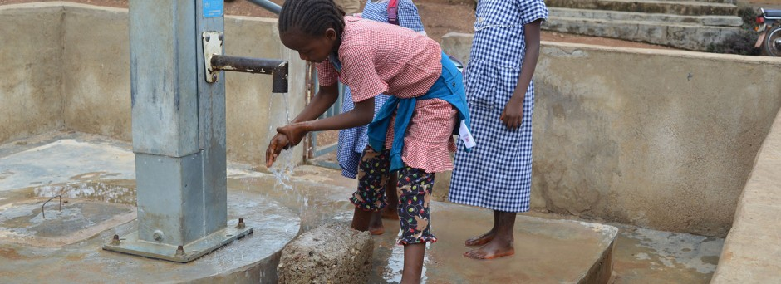

Improving Sustainable Water Access to Rural Communities in Guinea

overview
The Ebola outbreak of 2014-2016 highlighted the need to strengthen water, sanitation and hygiene (WASH) health-related preventive measures at all levels in Guinea. Safe drinking water and adequate sanitation are essential for life and health. A sustainable supply of safe water, adequate sanitation and improved hygiene not only saves lives, but also has significant effects for girls and women, who bear primary responsibility for fetching water, which is often unclean and far from home. This daily chore exposes them to the potential risk of violence and can prevent girls from attending school. UNICEF believes that access to WASH goes far beyond health improvements, positively affecting areas such as human rights, girls’ education, gender relations and nutrition.

Rural communities in Guinea remain poorly served with too few sources of safe water in areas that are too widely spaced apart. In 2015, 32 percent of the population consumed contaminated water. With WASH services still recovering from the largest Ebola outbreak in human history, children in Guinea remain vulnerable to preventable illnesses and diseases.

The importance of safe water
When you give a child safe water, you don’t just give them life, you give them health, an education and a brighter future.

- When children rely on dirty water, they are at risk of deadly diseases. Young children are particularly vulnerable to water and sanitation-related diseases, which remain among the leading causes of death in children under five.
- When girls don’t have to walk for hours to collect safe water, they can go to school. When that school has clean and gender-separated toilets, they don’t have to skip class when they have their period. For many girls, access to safe water and basic toilets is the foundation for equality.
- Safe water is essential for health care, including in maternity wards where without safe water and soap, midwives will have to deliver children without being able to wash their hands.
- Safe water is also an important component of nutrition – if a child has food but no safe water, the food they consume will not nourish them properly. In Guinea, 31 percent of children under 5 are stunted as a result of malnutrition, the physical and mental effects of which can be irreversible.

UNICEF in Action
UNICEF uses manual drilling technology in Guinea to reduce the cost of water points in hard-to-reach locations and to build expertise in their maintenance within communities. Mechanical drilling rigs are more expensive to use because of fuel and transportation costs, and the roads in certain rural areas are unable to support the heavy machinery, making their use impossible. By contrast, manual drilling is not only less expensive and the equipment easier to transport, but high community involvement in the process leads to building up local business enterprises, expertise and interest in maintaining and repairing wells and hand pumps.

The core of UNICEF’s approach is to build the skills of local artisans and private sector capacity for manual drilling by providing the tools and training required to meet the demand for safe water beyond donor assistance. UNICEF supported a successful pilot manual drilling project from 2014 – 2017 that benefitted nearly 84,000 people in rural Guinea, bringing them a sustainable supply of safe water.

The Impact of Your Support
Phase 2 of the project will build on the success of the pilot phase and scale up sustainable access to safe water in remote villages in Guinea. Phase 2 will cover 34 rural municipalities in the regions of N’Zérékoré and Labé over four years, benefitting at least 210,148 people, including through the addition of some solar powered water and piping systems that help mitigate the effects of drought. This number includes 20 municipalities in which existing boreholes will be retrofitted with solar powered pumping and water systems and at least 167 villages where up to 200 boreholes will be drilled. UNICEF will also promote good hygiene practices to help reduce water-borne diseases in rural communities.

Three specific objectives for the project are:

- Scale up access to safe water for rural communities/villages through low cost water supply technology options;
- Empower rural communities to adopt good hygiene practices; and
- Strengthen community-based management of water facilities and water supply infrastructure.

Outputs for Phase 2

- 34 rural municipalities in the regions of N’Zérékoré and Labé will be targeted over four years, benefitting at least 210,148 people (including 20 municipalities in which existing boreholes will be retrofitted with solar powered pumping and water systems and at least 167 villages where up to 200 boreholes will be drilled).
- Each village will establish a water committee that will be trained on the operation and maintenance of water facilities, water safety (storage and utilization) and how to address and promote behavior change on environmental and climate change issues, such as the contamination of water reserves and a reduction in the quantity of water. Water committees will also manage payments for the use of water by community members.
- Community awareness campaigns will be carried out in villages, engaging approximately 330,930 people from core social groups (community and religious leaders, women and youth groups) and encouraging their participation in project activities.
- National water service (SNAPE) agents will be trained on community mobilization and governance.
- 34 water officers from the 34 targeted municipalities will be trained on social mobilization and management of water interventions, specifically on monitoring and evaluation, technical supervision and pump monitoring.
- A local company will be identified to design and manufacture hand pumps for the project.

Funding Need
While the four-year total project budget is $4,155,796. With NextGen’s support of $200,000, which will be generously matched up to $100,000 to bring the total support to $300,000, UNICEF and partners could accomplish the following program activities:

- The manual drilling of approximately 54 wells; OR
- The manual drilling of approximately 12 wells equipped with solar powered water systems; OR
- Retrofitting approximately 5 existing wells with solar powered water systems.

To make a donation, please visit our donation page or reach out to Lilian Bancroft at (212) 922-2636. To learn more, contact UNICEF NextGen at nextgen@unicefusa.org.

